How to use a KML file

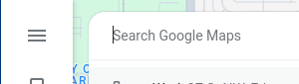
Step 1 – Open Google Maps

Step 2 – Click on three bars in the upper left corner
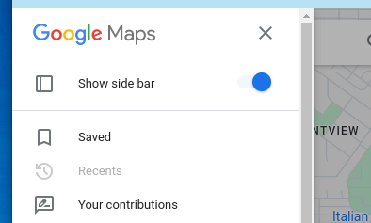

Step 3 – Click Saved

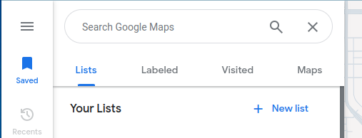
Step 4 – Click Maps

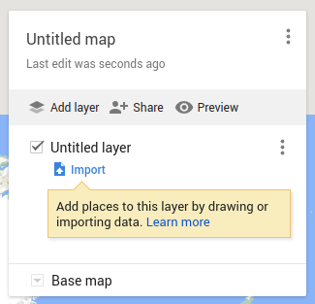

Step 5 – Click on CREATE MAPS (at the bottom)

Step 6 – Click on Import and follow the step

